**Practical No. 6B – T7**

**To design and develop web pages using HTML form and input elements**

Purva Kudre

2018BTECS00095

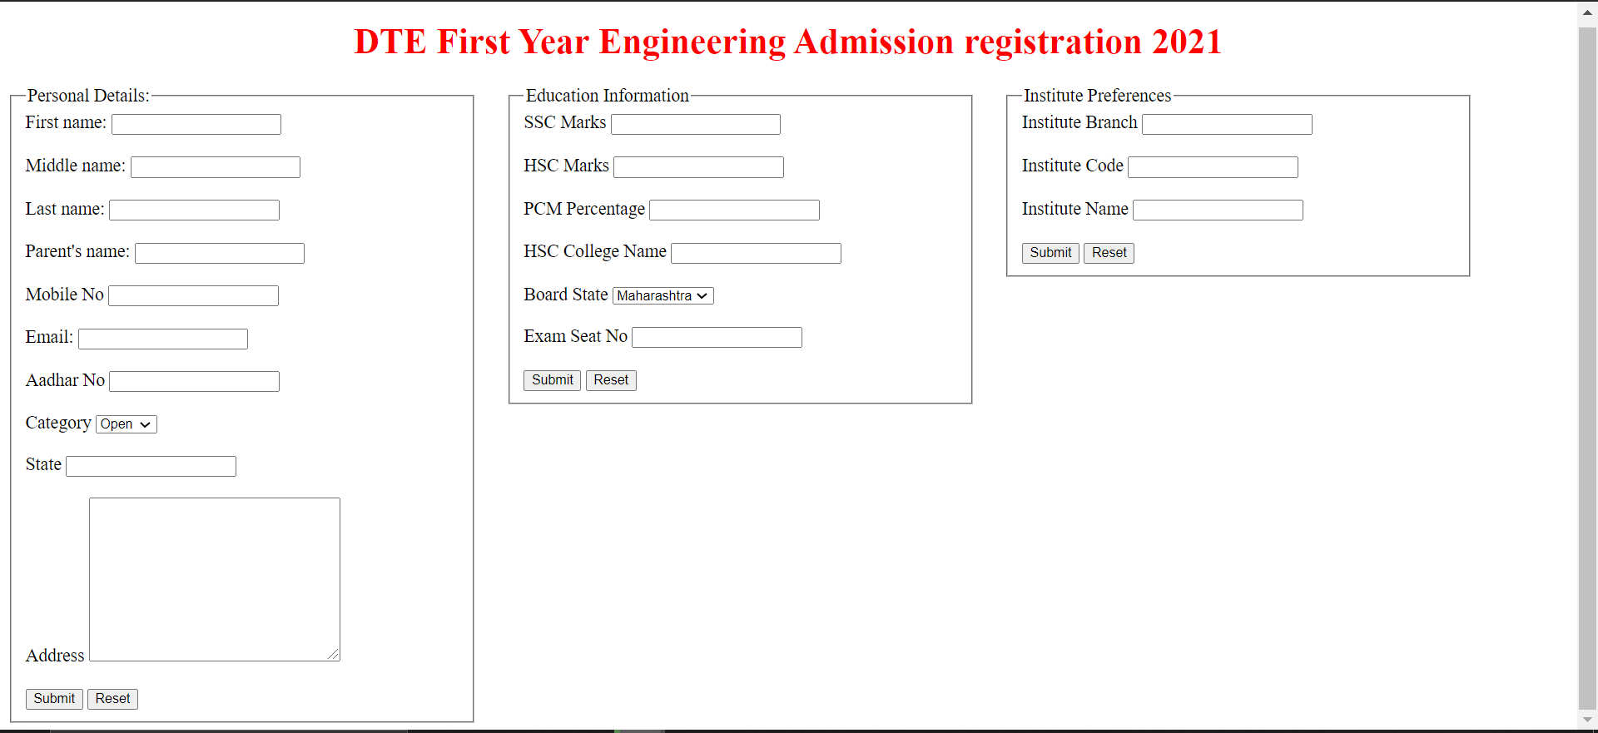

Github Link:-